**CS1113: SOFTWARE ENGINEERING**

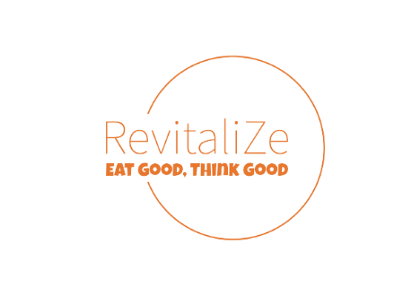

**FACULTY GUIDE**

Mr. Azad Bhagat Singh

**PREPARED BY:**

Daksh Kumar (12th-B 2023-24)



Computer Science

Vardhman International School, Jaipur

___________ 2023

**TABLE OF CONTENTS**

**CERTIFICATE** 3

**ACKNOWLEDGMENTS** 4

**ABSTRACT** 5

**OBJECTIVE** 6

**LIST OF FIGURES** 7

**INTRODUCTION** 8

Problem Statement 8

Model Adopted 9

**REQUIREMENT ENGINEERING & ANALYSIS** 10

**Feasibility Study** 10

Technical Feasibility: 10

Operational Feasibility: 10

User Requirements: 10

Entity Relationship Diagram: 11

**Software Requirement Specification** 12

Functional Requirements: 12

Non-Functional Requirements: 17

Software Requirements: 17

Flowchart & Diagrams: 18

**Software Testing** 23

Test Cases: 23

**FUTURE SCOPE** 26

**REFERENCES** 26

**Appendix** 26

# **CERTIFICATE**

This is to certify that **Daksh Kumar** of class **XII** of **Vardhman International School** has done his project on Examination Module for School under my supervision. He has taken interest and has shown at most sincerity in completion of this project.

I certify this Project up to my expectation & as per guidelines issued by **CBSE, NEW DELHI.**

-------------------------------------

Mr. Azad Bhagat Singh

HOD Computer

Vardhman International School, Jaipur

Date of Submission:

# **ACKNOWLEDGMENTS**

It is with pleasure that I acknowledge my sincere gratitude to our teacher, **Mr. Azad Bhagat Singh** who taught and undertook the responsibility of teaching the subject computer science. I have been greatly benefited from his classes.

I am especially indebted to our Principal **Ms. Malini Malik** who has always been a source of encouragement and support and without whose inspiration this project would not have been a successful I would like to place on record heartfelt thanks to him.

Finally, I would like to express my sincere appreciation for all the other students for my batch their friendship & the fine times that we all shared together.

Sincerely yours,

Daksh Kumar

# **ABSTRACT**

This project report introduces ‘ChunaaV’, a student-designed voting application. ‘ChunaaV’ simplifies the voting process by providing features for user registration, authentication, vote casting, and candidate information, all aimed at improving the voting experience.

The report briefly outlines the technology behind ‘ChunaaV’ including app development and file management. While acknowledging its limitations, ‘ChunaaV’ offers a straightforward solution for students and young users to engage in digital voting.

The app's potential for increasing participation among young voters is acknowledged, though this report mainly focuses on its development model and core features. ‘ChunaaV’ represents an exciting venture into online voting and civic engagement for students.

# **OBJECTIVE**

Objective of ChunaaV is

1. To simplify and enhance the electoral process for all users.
2. To encourage higher voter participation in elections.
3. To ensure the security and authenticity of all votes cast.
4. To make voting more accessible and convenient for all citizens.
5. To promote active civic engagement and democratic participation.
6. To make it easy to share and review the result.

# **LIST OF FIGURES**

Figure 1: ER Diagram 11

Figure 2: RevitaliZe Landing Page 12

Figure 3: Dashboard 13

Figure 4: Remedies 13

Figure 5: Remedies for specific medical conditions 14

Figure 6: PDF with remedies and food to avoid 14

Figure 7: Reminder 15

Figure 8: User's Feedback 15

Figure 9: Doshas Report 16

Figure 10: PDF of Doshas Reports 16

Figure 11: Context Diagram 18

Figure 12: Level-0 DFD 18

Figure 13: Level-1 DFD 19

Figure 14: Module Structure 20

Figure 15: Use Case Diagram 20

Figure 16: Flowchart 21

Figure 17: Activity Diagram 21

Figure 18: Sequence Diagram 22

# **INTRODUCTION**

## **Problem Statement**

In the current electoral landscape, traditional voting processes face challenges that hinder broad civic engagement. Long queues, limited accessibility, and the need for physical presence often deter potential voters from participating in elections. Additionally, there is a lack of personalized guidance and comprehensive information about candidates, making it challenging for voters to make informed choices. This app aims to address these issues and provide a convenient, secure, and inclusive platform for citizens to exercise their democratic right to vote.There have been a lot of myths regarding food consumption. Counting calories while having food is not a sufficient parameter for having a healthy body. Everybody is unique, so the food consumption for each body will also be unique.

To solve this issue, we are recommending foods according to the body type of the person. We are using Ayurvedic Doshas to know the body type of the person.

Doshas are the Ayurvedic secret of knowing the root cause of any disease. There are three doshas i.e. Vata, Pitta, and Kapha. These doshas get their qualities from the combination of five elements in nature i.e.,

* Water
* Earth
* Fire
* Space
* Air

Vata dosha is the result of air and space, Pitta Dosha is caused by the fire element, Kapha dosha is a result of earth and water elements.

All of us are different, we all have different types of bodies, deposition, illnesses, lifestyles and varying personalities.

According to the science of Ayurveda, these differences are called Prakruti. A person’s prakruti could be governed by one or a combination of the three doshas because our body is made up of natural elements.

We recommended the renowned Ayurvedic Doctor for the data. We have taken a survey from various people about what health conditions they are having. According to the survey, we collected the data in a few categories to suffice the need of each user.

## **Model Adopted**

We adopted Agile Model to implement this project. Agile Model, is commonly used in all companies. In the Agile model, following steps are there:

Breaking into smaller chunks → Release → Feedback → Feedback → Enhance → Re-release

Agile Model deals with frequent delivery of the project, intensive communication with clients, and enhancing the project after receiving feedback from the client.

The problem of less documentation & maintenance arises due to iterative developments & the amendments being done after the client's feedback.

We used this model in our project in such a way:

We divided the project into smaller chunks (i.e., features). Initially, we made a Questionnaire page, & Dashboard in which remedies & dosha report is successfully working. After getting the feedback, we made a few amendments by adding medical conditions. If the user is already having some medical condition, then a few remedies won't work for them and instead will deteriorate their health. Therefore, we added a few medical conditions as well as the feedback option which the user will fill in & the doctor will be able to see it anonymously for better results. We also received one more piece of feedback from the client to all list the avoids according to the Dosha Report.

# **REQUIREMENT ENGINEERING & ANALYSIS**

## **Feasibility Study**

A feasibility study is an analysis to determine the viability & practicality of the proposed software project.

### Technical Feasibility:

After intensive research and analysis from a technical aspect. The technical requirements of the project pass the technical feasibility.

We can conclude it with the following statements:

1. The added libraries such as ReactJs, & APIs(from the Twilio website)for sending messages on WhatsApp are trusted, understandable, and easy to access.
2. The chosen database (i.e., MongoDB) for the database is also understandable and works best with unstructured data, so it's great for Big Data systems. We are using MongoDB Atlas.

### Operational Feasibility:

After intensive research and analysis. We can conclude that the platform can be implemented and operated effectively. It can also be integrated with existing systems and processes.

### User Requirements:

1. Identify the uniqueness of their respective body.
2. Get recommendations for healthy and wholesome food for nourishing the mind, body, and soul.
3. Customized Remedies according to the body type by the authorized doctors.
4. Keeping the medical condition of the respective user in mind while customizing the remedies.
5. Reminders to notify the user to follow up on the remedies.
6. Feedback from the user regarding the problem faced by them.

### Entity Relationship Diagram:

In ER Diagram, we are making eight tables (i.e., collections). Firstly, the users table which we will be used to store user details such as name, age, gender, unique email id, unique phone number along with the password. The _id which is automatically created in mongoDB while posting data in the database. This id is used as the foreign key in various tables to access the data of the respective user. The remedies database is a little bit complex which includes all three doshas, and medical conditions (i.e., Eczema, Hypothyroidism, Hyperthyroidism, PCOD), and the type of remedy along with its name & description.

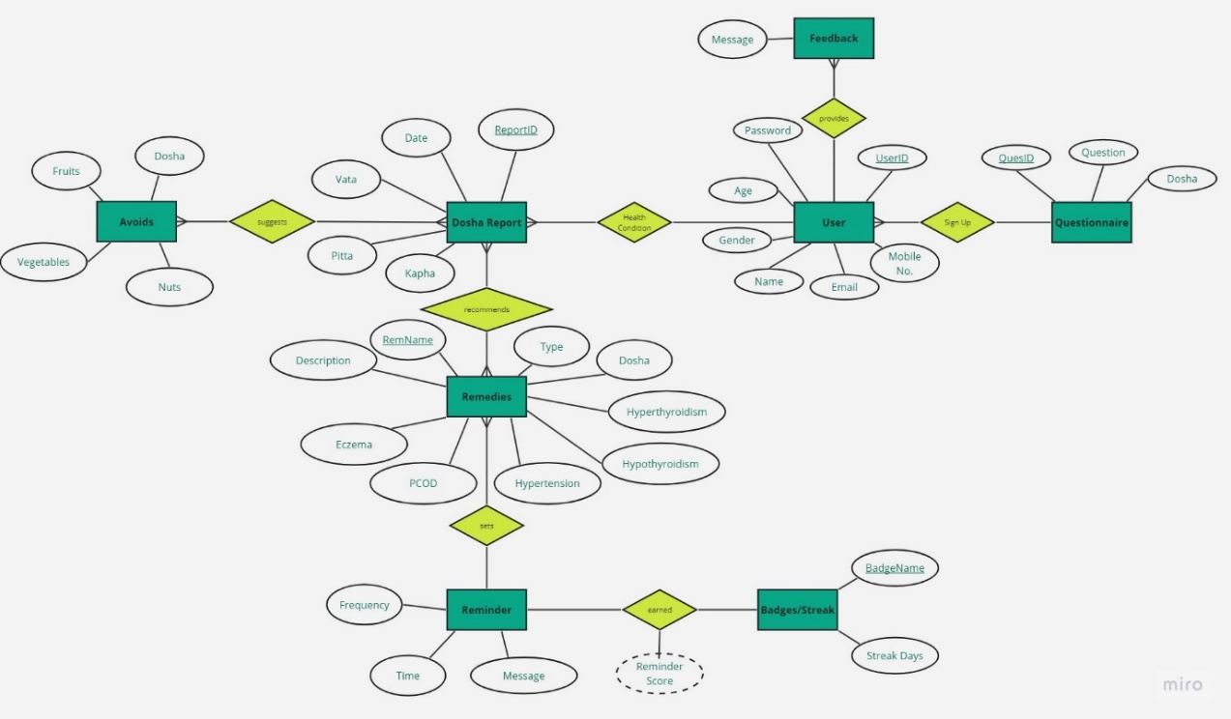

Figure : ER Diagram

## **Software Requirement Specification**

### Functional Requirements:

Functional working of our project is as follows

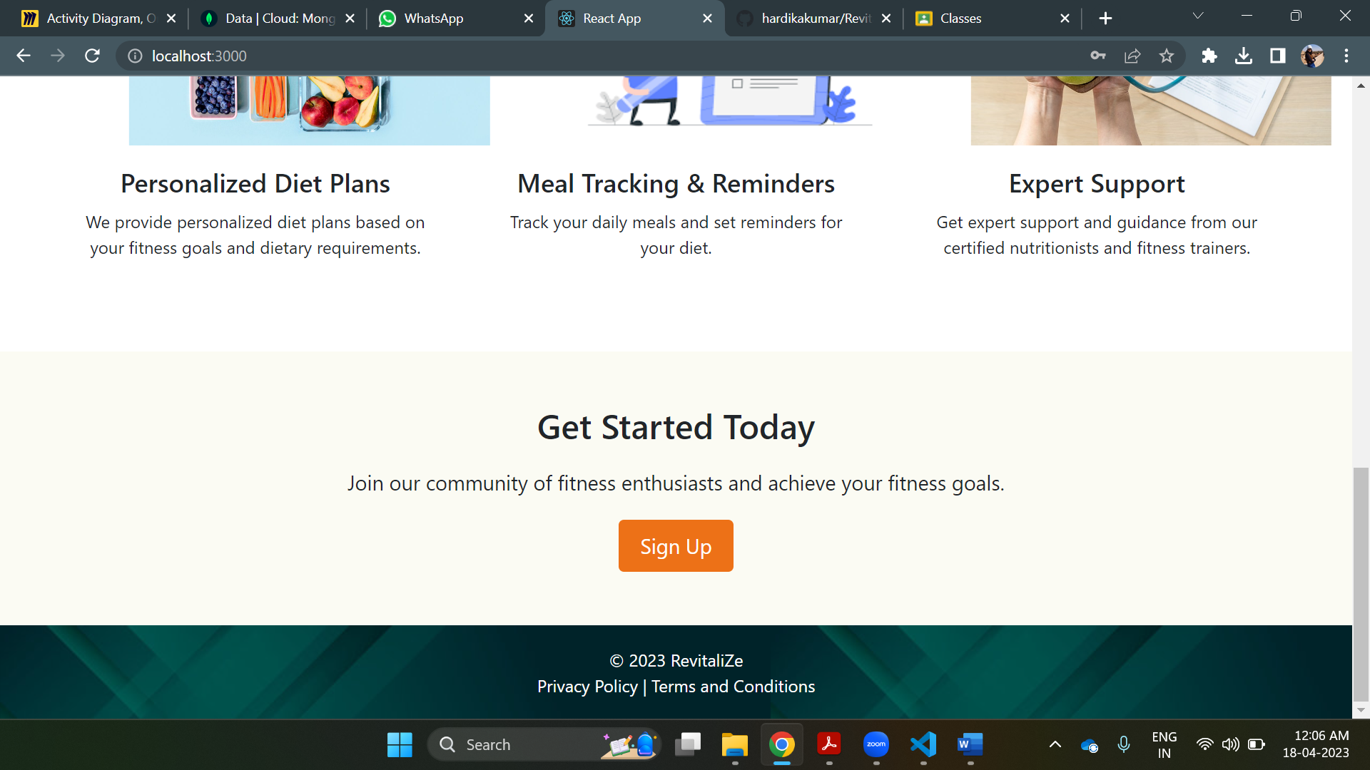

Figure : RevitaliZe Landing Page

After filling out all the questions on the questionnaire page we proceed to the user's dashboard where Doshas Scores are visible for the user and in the sidebar remedies, reminders, feedback & Dosha Reports.

Figure : Dashboard

When you will click on the remedies button medical conditions will be displayed on the screen.

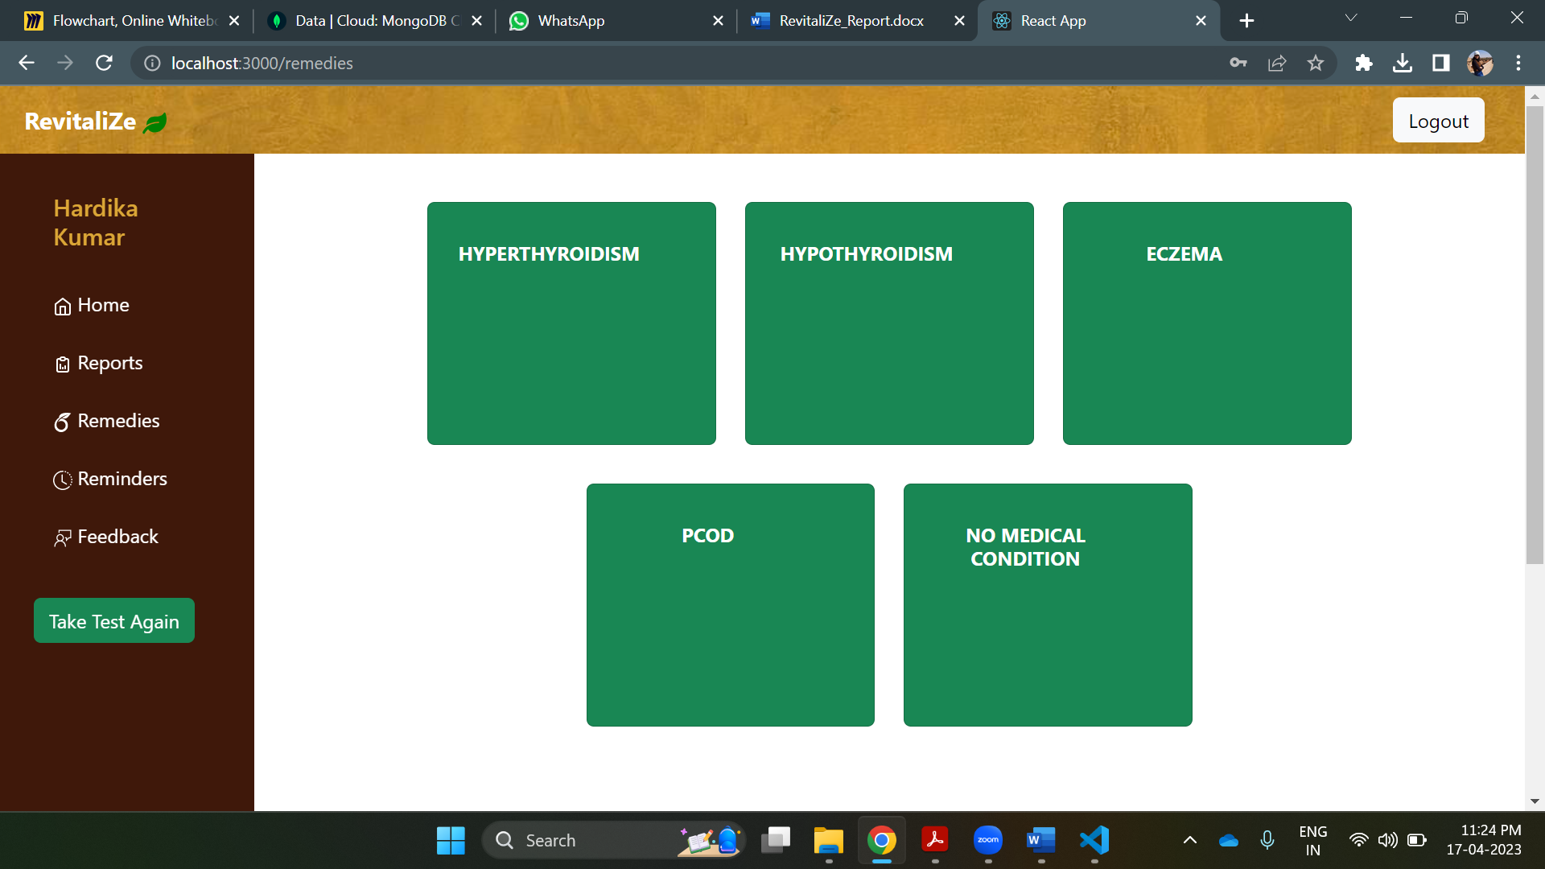

Figure : Remedies

After selecting the medical condition, the remedy according to the Dosha Scores, & medical condition will be displayed on the screen along with avoids.

Figure : Remedies for specific medical conditions

Remedies include fruits, vegetables, oils, grains, spices, & nuts & seeds along with their respective description. Detailed report of remedies along with food to avoid can be viewed and downloaded in pdf format, by clicking on ‘Get complete Report’.

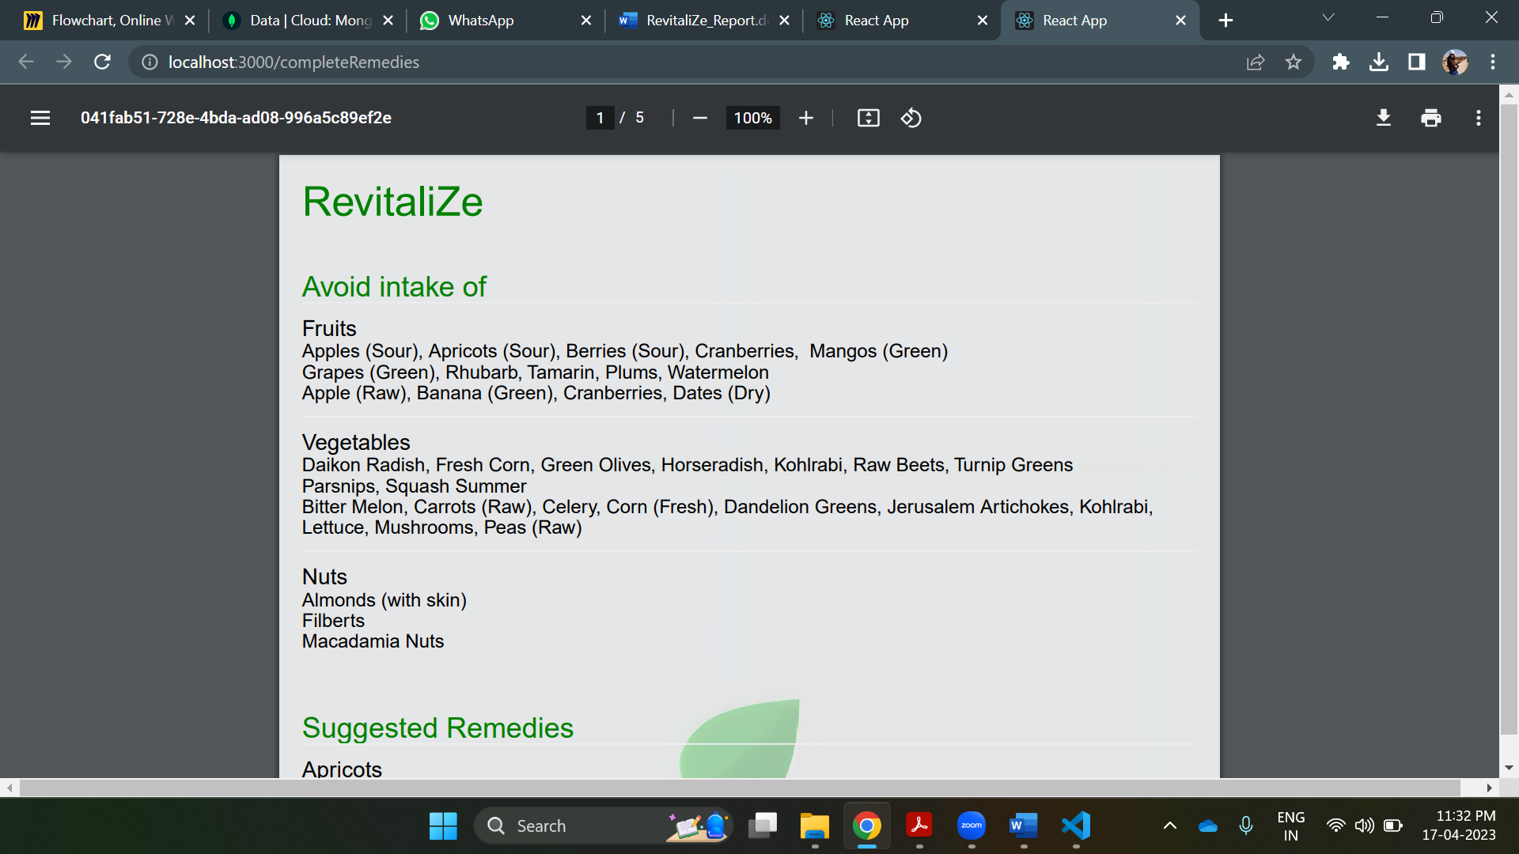

Figure : PDF with remedies and food to avoid

If you wish to select the remedy as the reminder you can click on the Set Reminder button. The reminder can be set with its name, frequency, date & time.

Figure : Reminder

To add feedback on the remedies you have consumed or regarding the dosha Report click on the feedback button and can simply write down your feedback on the modal popped on the screen.

Figure : User's Feedback

To view the past Dosha Reports, click on the Reports in Side Bar, latest five dosha reports are visible on the screen.

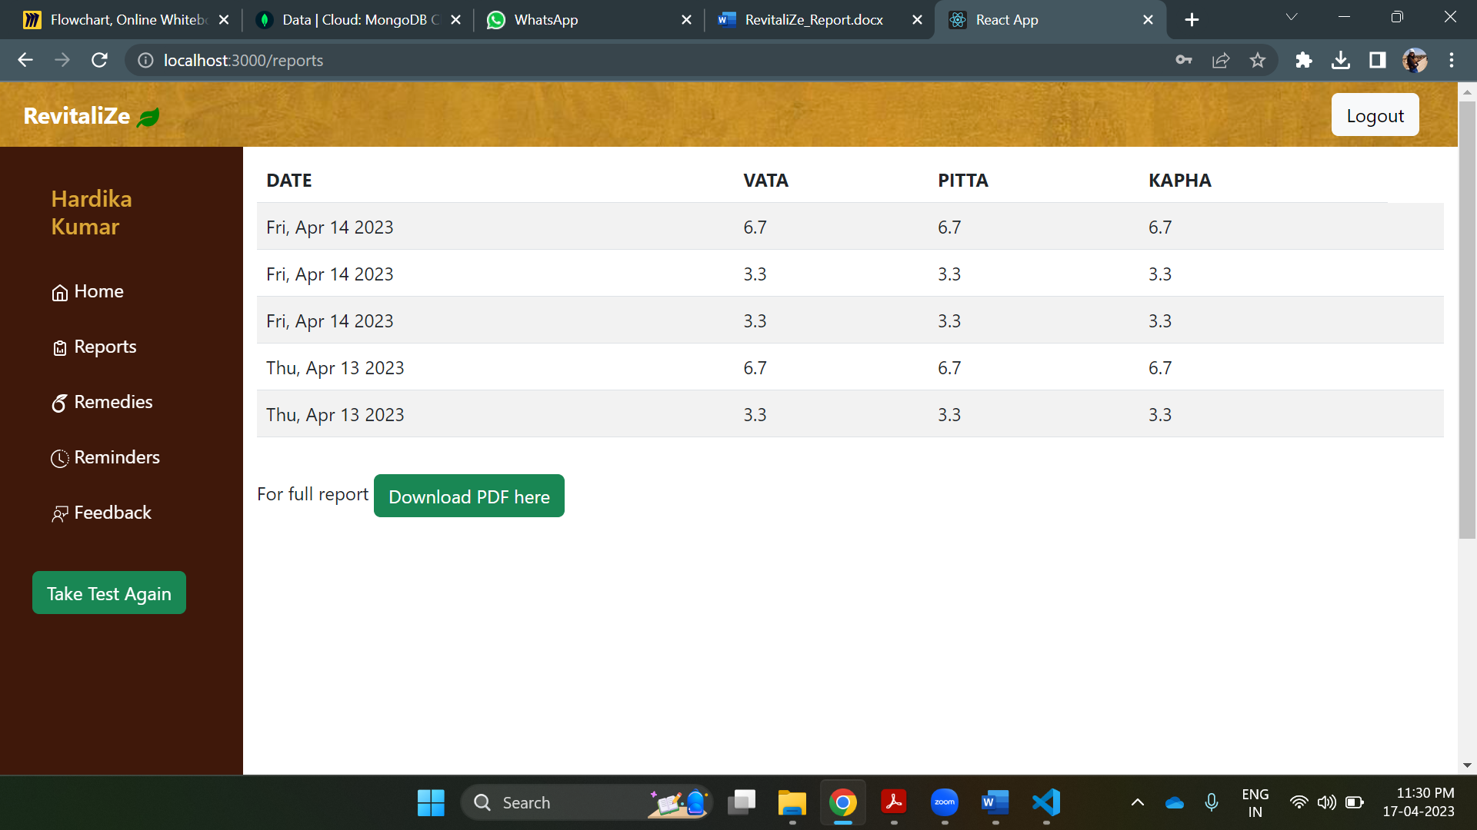

Figure : Doshas Report

To view the full Dosha Report click on the ‘Get Full Report’ button to view/download full report in pdf format.

Figure : PDF of Doshas Reports

### Non-Functional Requirements:

We have authenticated the user in such manner:

1. While signing up phone number & email id should be unique else the user won't be able to sign up.
2. The password used as a login credential is stored in the database in encrypted format using SHA-256.

The performance of the website is high, each page is intended within a second, and as soon as the user clicks on the remedy option immediately remedies will be displayed on the pop-up screen.

For Storage Atlas MongoDB is used which is used for Big Data Systems.

The website will be efficiently accessible even if the number of users increases because of the cloud databases.

The website is recoverable if any of the glitches arise in the website.

### Software Requirements:

ReactJS: ReactJS is an open-source JavaScript library used for building User Interfaces. In ReactJS developers are allowed to build reusable UI components and can assemble them to create complex user interfaces. It is widely used in the web development industry and has a large and active community of developers and contributors.

MongoDB: MongoDB is a popular open-source NoSQL document-oriented database that stores data in flexible, JSON-like documents. MongoDB is highly scalable. It provides several optimization features that improve the speed & efficiency of the query.

Twilio: Twilio is a cloud communication platform that provides APIs (Application Programming Interfaces) for developers to add messaging, voice, and video capabilities to their applications.

### Flowchart & Diagrams:

Context Diagram

Figure : Context Diagram

Level-0 DFD

Figure : Level-0 DFD

Level-1 DFD

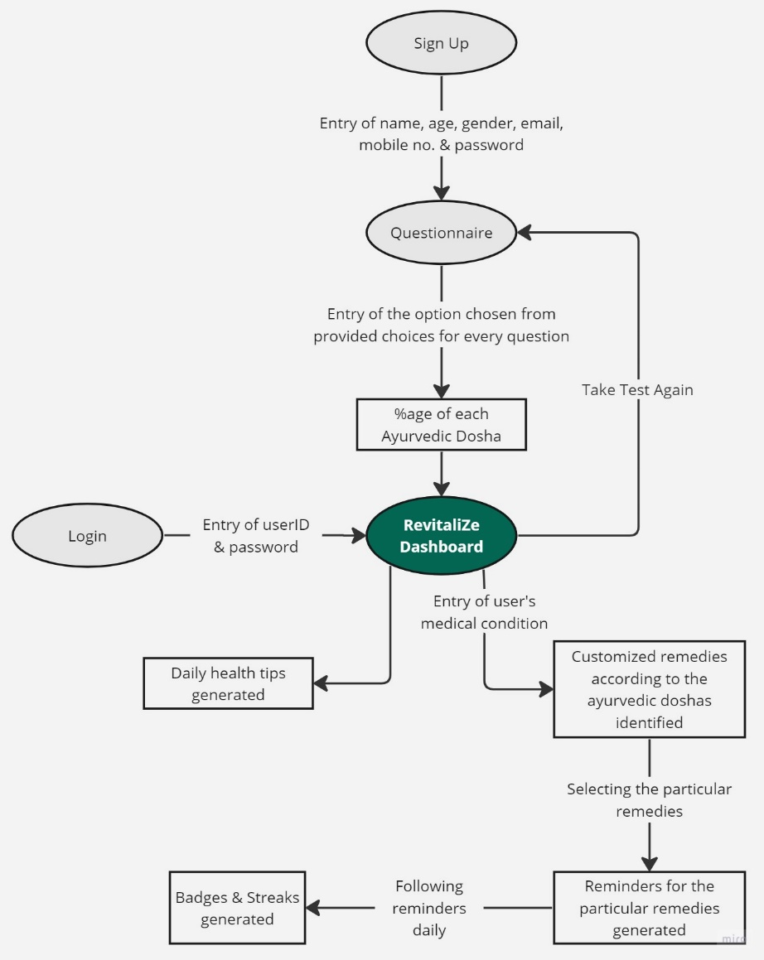

Figure : Level-1 DFD

Module Structure

Figure : Module Structure

Use Case Diagram

Figure : Use Case Diagram

Flowchart

Figure : Flowchart

Activity Diagram

Figure : Activity Diagram

Sequence Diagram

Figure : Sequence Diagram

## **Software Testing**

Test cases are a set of conditions or inputs that are used to determine the correctness or quality of a software system. They are created to validate that the software functions as intended and meets the requirements and expectations of the users. Test cases help detect errors early, improve software quality, reduce maintenance costs, enhance user experience, and increase confidence in the software.

### Test Cases:

|  |  |  |  |
| --- | --- | --- | --- |
| **TEST CASES FOR REVITALIZE** | | | |
| **Arushi Singh (2020BTechCSE012)** | |  |  |
| **Hardika Kumar (2020BTechCSE033)** | |  |  |
|  |  |  |  |
| **Steps No** | **Description** | **Inputs** | **Expected Result** |
| **1** | **SIGNUP FORM** |  |  |
| **1.1** | Enter the following values for **name** | &^$-_ | Reject |
|  |  | null | Reject |
|  |  | 527 | Reject |
|  |  | -374 | Reject |
|  |  | Adarsh | Accept |
|  |  | Adarsh Shah | Accept |
|  |  | Adar$sh Hd21 | Reject |
|  |  |  |  |
| **1.2** | Enter the following values for **email** | arushisingh0011@gmail.com | "Already Registered" |
|  |  | arushisingh0011 | Reject |
|  |  | 11 | Reject |
|  |  | gmail.com | Reject |
|  |  | -arushisingh0011@gmail.com | Reject |
|  |  | #hardika**kumar2368@gmail.com | Reject |
|  |  | null | Reject |
|  |  | #@$@#323242ffdgs | Reject |
|  |  | hardikakumar0711@gmail.com | Accept |
|  |  |  |  |
| **1.3** | Enter the following values for **age** | 10 | Accept |
|  |  | 99 | Accept |
|  |  | -10 | Reject |
|  |  | 0 | Reject |
|  |  | 100 | Reject |
|  |  | abc | Reject |
|  |  | 10 | Reject |
|  |  | 9 | Reject |
|  |  | null | Reject |
|  |  |  |  |
| **1.4** | Enter the following values for **passcode pin** | asdb | Reject |
|  |  | 1234 | Accept |
|  |  | asnjb34 | Reject |
|  |  | 12493462 | Reject |
|  |  | 23 | Reject |
|  |  | 236 | Reject |
|  |  | 68230 | Reject |
|  |  | @1byA | Reject |
|  |  | -234 | Reject |
|  |  | vg@3 | Reject |
|  |  | Ha7# | Reject |
|  |  | iH&9 | Reject |
|  |  | 8hK7 | Reject |
|  |  | +82hK | Reject |
|  |  | 2372742-349 | Reject |
|  |  | null | Reject |
|  |  | 1 | Reject |
|  |  |  |  |
|  |  |  |  |
| **2** | **LOGIN PAGE** |  |  |
| **2.1** | Username & Passcode Pin | null,null | "Credentials should not be empty" |
|  |  | null,1234 | "Email Id should not be empty" |
|  |  | [arushisingh0011@gmail.com,null](mailto:arushisingh0011@gmail.com,null) | "Passcodepin should not be empty" |
|  |  | sdugfbogvdaudfgj | Invalid Input |
|  |  | 238gfkt48fgtb,45t4 | Invalid Input |
|  |  | arushisingh0011@gmail.com,1234 | "Login Successfull" |
|  |  | arushisingh0011@gmail.com,1243 | "Passcode pin didn't match" |
|  |  | hardikakumar1107@gmail.com | "Not Registered Yet" |
|  | Enter four digit passscode pin | 1256 | Accept |
|  |  |  |  |
| **2.2** | At the server side, passcode pin will be encrypted in SHA-256 format | "a665a45920422f9d417e4867efdc4fb8a04a1f3fff1fa07e998e86f7f7a27ae3" | Accept |
|  |  |  |  |
| **2.3** | The encrypted passcode pin is stored in MongoDB cloud database in users collection | _id 6419e4c9f06311799633cee6 name "Aru Singh" age "21" gender "F" email "arushisingh0011@gmail.com" encryptedPasscode "a665a45920422f9d417e4867efdc4fb8a04a1f3fff1fa07e998e86f7f7a27ae3" | Accept |
|  |  |  |  |
|  |  |  |  |
| **3** | **ROUTING** |  |  |
| **3.1** | Click on the About page in the navbar | /About | About page containing description of Ayurveda displays |
| **3.2** | Click on the Daily Health Tips page in the navbar | /DailyHealthTips | One health Tips displays |
| **3.3** | Click on the Daily Health Tips page in the navbar again | /DailyHealthTips | Different health Tip should be displayed from the previous one |
| **3.4** | After clicking on the LOGIN button. The questionnaire page should be displayed | /Questionnaire | The first question regarding dosha should be displayed |
|  |  |  |  |
|  |  |  |  |
| **4** | **QUESTIONNAIRE** |  |  |
| **4.1** | Click on next button | Selected an option | Allow |
|  |  | Selected NO option | Don't Allow |
|  |  |  |  |
| **4.2** | Submit | Answered all questions | Allow |
|  |  | All questions not answered | Don't Allow |

# **FUTURE SCOPE**

1. If the person wishes to seek advice directly from the doctor, we can schedule a meeting for them.
2. We will be adding more medical conditions and expanding our database.
3. More healthy tips will be added, and the health tips will be displayed randomly on the screen.
4. Forgot Password option will be added on the login page.
5. For two-way authentication, OTP will be sent while signing up & login.
6. For doctors, digital signature verification will be done while doing sign-up.
7. A yoga option will also be there if the user wishes to do yoga according to his respective disease. Respective Yoga videos will be displayed on the screen.
8. Streaks & Badges option will be available for motivation.

# **REFERENCES**

* PDF. React-pdf. (n.d.). Retrieved from https://react-pdf.org/
* Hankey, A. (2005). The scientific value of Ayurveda. *Journal of Alternative & Complementary Medicine*, *11*(2), 221-225.
* Joshi, R. R. (2004). A biostatistical approach to Ayurveda: quantifying the Tridosha. *Journal of Alternative & Complementary Medicine*, *10*(5), 879-889.
* Suguna, G. C., Veerabhadrappa, S. T., & Gosh, A. (2022, December). Acquisition and Identification of Vata, Pitta and Kapha of an individual. In *2022 Fourth International Conference on Cognitive Computing and Information Processing (CCIP)* (pp. 1-9). IEEE

# **Appendix**

GitHub Repository Link: <https://github.com/hardikakumar/RevitaliZe>